No | Item | Photo | Price
 | Maths Game Sum Swamp | 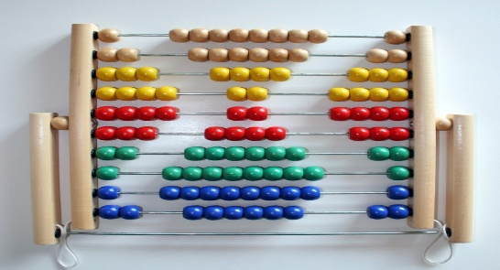
 | Ravensburger tiptoe Starter Set | 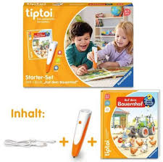
 | Learning Resources STEM | 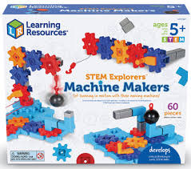
 | Explorers Brainometry Game | 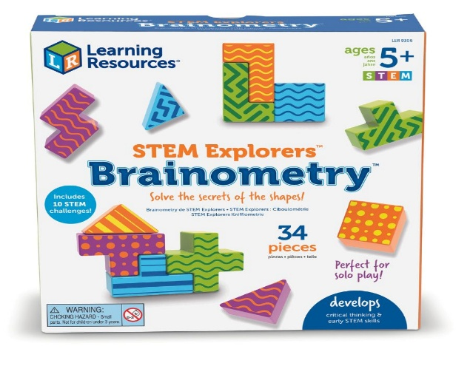
 | Explorers Brainometry Game | 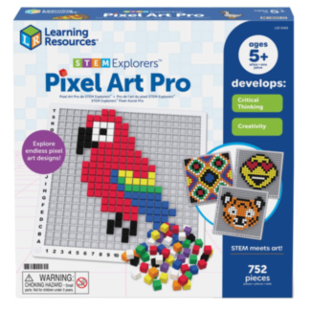
 | Learning Set (11–13 yrs) | 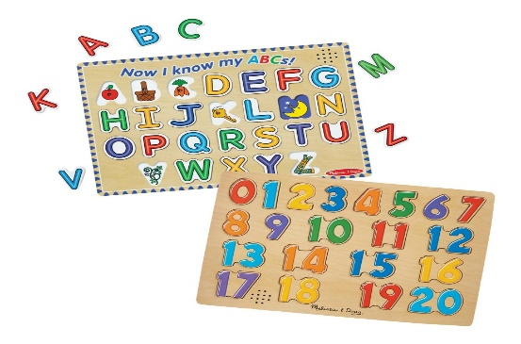
 | National Geographic Mega Earth Science Kit Toolbox | 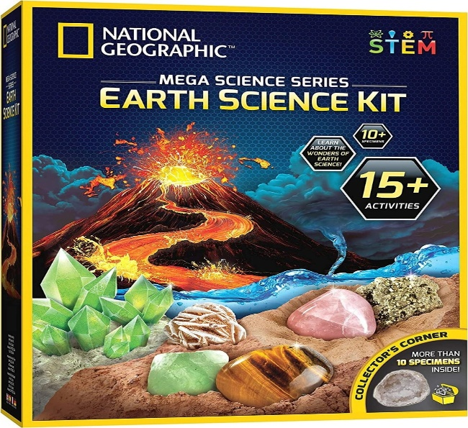
 | Build-A-Word Magnetic | 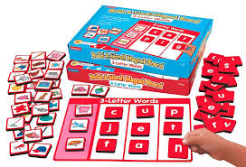
 | Arabic Letters Set Kids | 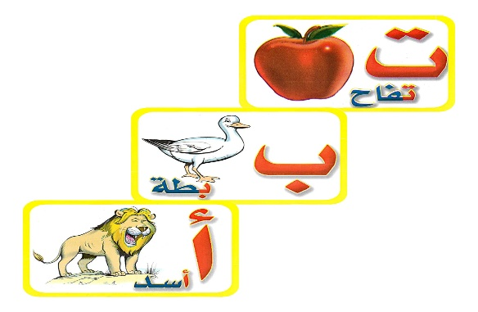
 | Box: Arabic Learning Arabic | 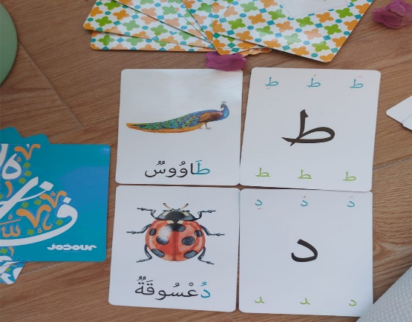
 | Alphabet Talking Flashcards | 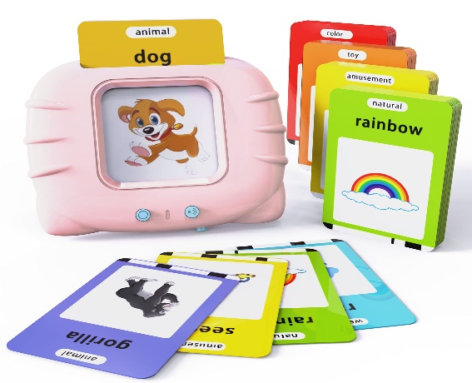
 | Arabic Alphabet | 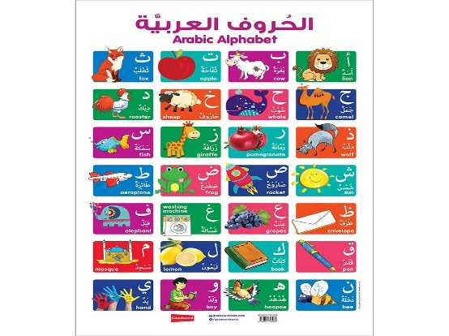
 | Snap Arabic in a Flash Kit Volume 2 | 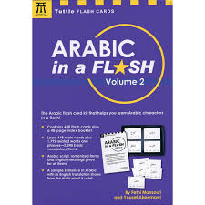
 | Desi Doll Arabic Alphabet Sound Puzzle | 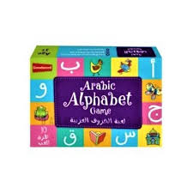
 | Football (Ball - Net - Goal posts) | 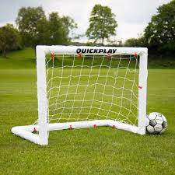
 | 16- Volleyball (Ball - Net - Volleyball posts) | 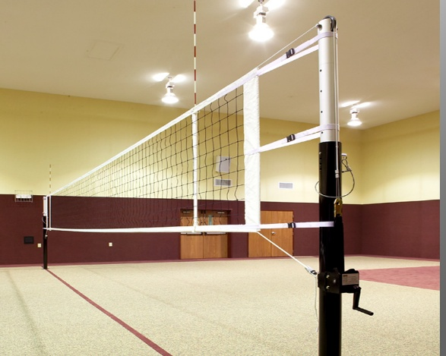
 | 17 - Jump rope | 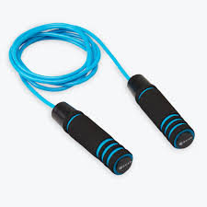

1-Maths Game Sum Swamp
2-Ravensburger tiptoe Starter Set
3-Learning Resources STEM
4- Explorers Brainometry Game
5- Learning Resources Home
6- Learning Set (11–13 yrs)
7- National Geographic Mega Earth Science Kit Toolbox
8- Build-A-Word Magnetic
9- Arabic Letters Set Kids
10- Box: Arabic Learning Arabic
11- Alphabet Talking Flashcards
12- Arabic Alphabet
13- Snap Arabic in a Flash Kit Volume 2
14- Desi Doll Arabic Alphabet Sound Puzzle
15- Football ( Ball - Net - Goal posts)
16- Volleyball (Ball - Net - Volleyball posts)
17 - Jump rope

